
Editors Comments

Well hello again, I hope that everyone had a good Christmas and a Happy New Year. It seems that spring is now well on the way, my snowdrops have been in flower since 28th December but are suffering in the heavy snow, which I woke up to this morning. I hope you are remembering to put some scraps and fresh water out for our feathered friends in this cold weather, if you do you will be rewarded by being able to listen to their songs and watch their antics right outside your window.

Here is a silly little rhyme, which my mother used to say
Spring is sprung
The grass is ris
I wonder where the birdies is?
The bird is on the wing
But that’s absurb
Because the wing is on the bird!

I don’t know who wrote it but I think it’s funny. Answers on a postcard please!

In this edition of ‘The Key’ I unintentionally seemed to have concentrated on sports and fitness. You may not think this is of interest to you, but have a read of the article on pages 29-31 which points out the benefits to us all of staying as fit and active as possible. From our indoor ‘have a go’ sports day on 26th April (page 9), to ‘Exercises for people with MS’ (pages 12-15) to Shepshed Disabled ‘Have a Go’ Day (page 18) to the Active Lifestyle Programme (pages 32-33) there is something there to suit everyone, I’ve noticed that even our item ‘For Sale’ on page 26 is a Therapeutic Exerciser!

I treated myself to a wonderful little book a few weeks ago and thought I would share it with you. It is called ‘Change the World for a Fiver’ produced and published by a community project named ‘We Are What We Do’ which is very much my philosophy too. There is a website of the same name www.wearewhatwedo.org
Well, here are just a couple of thoughts and ideas from this book, which we can all do to make a difference.
Turn off unnecessary lights
Put your chewing gum in the bin
Smile and smile back (this really works, try it!)
Turn your thermostat down by 1°
Get fitter, feel better (see pages 29-33)

So as you can see these actions won’t cost you anything, but if we all do them, it should improve our lives and those of others.

Anyway, that’s enough of me waffling on, come on everybody where are all your articles? I can’t keep coming up with new things every time, please send me funny stories, poetry, recipes, handy hints etc, etc.


The Mobility Roadshow
Donington Park
7th – 9th July 2005

Open Daily from 10am – 5pm

This is the world’s largest outdoor mobility event and it is right on our doorstep!

If you have a mobility problem you can’t afford to miss this roadshow. There are many organisations taking part, including car companies, vehicle adaptation companies, scooter, wheelchair and mobility aids manufacturers as well as ramps, hoists, stairlifts and walking aids from a wide range of exhibitors.

Admission and showguides are FREE

Why not pre-book the loan of a wheelchair or scooter to help you get around.

For further details call: 0870 770 3222
e-mail: choice@gtnet.gov.uk
www.justmobility.co.uk
Some very wise words………

Value

A well known speaker started off his seminar by holding up a £20 note. In a room of 200, he asked who would like the £20 note? Hands started going up.

He said “I am going to give this £20 to one of you, but first let me do this.” He then proceeded to crumple up the note. Then he asked “who still wants it?” Still hands were up in the air.

“Well”, he replied, “what if I do this?” He dropped it to the ground and started to grind it into the floor with his shoe. He picked it up, now crumpled and dirty. “Now, who still wants it?” Again the hands went into the air.

My friends, we have all learned a very valuable lesson. No matter what I did to the money, you still wanted it because it did not decrease in value. It is still worth £20.

Many times in our lives, we are dropped, crumpled, and ground into the dirt by the decisions we make and the circumstances that come our way. We feel as though we are worthless. But no matter what has happened or what will happen, you will never lose your value – dirty or clean, crumpled or finely creased, you are still priceless to those who love you.

The worth of our lives comes not in what we do or who we know, but in who we are. You are special … don’t ever forget it!

If you do not pass this on, you may never know the lives it touches, the hurting hearts it speaks to, or the hope that it can bring. Count your blessings, not your problems. Never be afraid to try something new.

Remember that amateurs built the Ark.
Professionals built the Titanic.
*************************************************
STOP PRESS STOP PRESS
You may remember in the last ‘Key’ magazine I mentioned going to the cinema. Well, since 1st January 2005 a few things have changed. Apparently a few people have been abusing the carer going free, so now some cinemas require proof that you are disabled!
For instance at the Odeon cinemas you must apply for a Carer’s Card which will allow your carer free admittance. The card costs £5.00 and is valid for three years. To obtain an application form phone 0116 2558168 or you can download one from www.ceacard.co.uk.

The MS Nurses, Alison, Fiona and Deborah have now moved to:-

The Neurology Outpatients Department
Leicester General Hospital
Gwendolen Road
Leicester
LE5 4PW

The new telephone numbers are;

MS Nurses (answer machine)
0116 2584700

MS Clinic Co-ordinator
0116 2584250

Neurology Counsellor
0116 2584492

~~~~~~~~~~~~~~~~~~~~~~~~~~~~~

NOTICE

THE 45th ANNUAL GENERAL MEETING OF THE
MS LEICESTER BRANCH IS TO BE HELD AT
12.30pm
TUESDAY 26th MARCH 2005
AT THE DROP-IN

EVERYONE WELCOME
~~~~~~~~~~~~~~~~~~~~~

Trips and Events that you have missed!!

Since Christmas, there haven’t really been any! Well, who wants to go out in the dark, cold and wet? But rest assured our programme of events will start to pick up again once the better weather arrives.

However several intrepid souls braved the cold, to rattle collecting tins at Tescos at Hamilton on Friday 11 February and Saturday 19 February and collected an amazing £820.00. Well done and thank you to everyone involved.

Forthcoming Day Trips/Events
Promise Auction St James the Greater
Friday 15 April 2005

A promise auction is to be held to raise funds for our branch. Please support this evening if possible by telling your friends and neighbours to go along and bid for some of the varied and interesting lots.


Ulverscroft Grange Tuesday 2 May

Arrive at 10.30 to take morning coffee, followed by a two course lunch and afternoon tea and cakes in the beautiful surroundings of this Grange. Weather permitting take a stroll outside and admire the gardens and enjoy the walk to Ulverscroft Manor, all easily accessible by wheelchair. Then reluctantly depart at about 3.00pm. What more could you ask for £6.00! This trip is limited to 12 people.

Ulverscroft Manor Thursday 18 August


Situated in the heart of the Charnwood countryside, why not visit Ulverscroft Manor. Whilst you are here take advantage of the woodland walk all easily accessible and take in the beauty of the surroundings. After morning coffee, a two course lunch is served followed at about 2.30-3.00pm by afternoon tea. What a shame we can’t stay the night as well! What a fantastic day out for only £6.00 per person, limited to a maximum of 18 people.


Peter Le Marchant boat trip Thursday 25 August

Once again we have booked this very popular trip. The places are strictly limited so book early to avoid disappointment!

Enjoy a welcoming drink on board Symphony, a specially adapted canal boat, as we cruise peacefully along the canal. Thenl stop for a pub lunch or you may prefer to bring your own picnic.

Do you support Leicester City?
Have you been to a match recently?

Well if the answer to the first question is yes and the second question is no, lets try and rectify this!

The following is written by Frank who regularly attends the ‘home’ matches along with Pete Bostock, Alan Chamberlain and Richard Stapley.

Leicester City Football Club is so easy to go to in a wheelchair. Limited parking is available at the ground but cars aren’t released until the crowd has dispersed which takes approximately half an hour. So, we opt to park at the therapy centre at Freeman’s Common and walk in. On arrival at the ground you thump on your designated large door (no turnstiles for us) and friendly stewards let you in,check your ticket and if needed see you to your spot. These stewards also come round later with blankets to make sure you keep warm. We’ve opted to go on a raised platform in the South Stand (The Kop) holding about 14 wheelchairs and their carers. Into the lift we go and up one floor, this comes out in an area where our disabled toilet is situated and then up a ramp to drink in the magnificent Walkers Stadium. It is very impressive. By sitting with our back to the sun we never
get it in our eyes.

Alan sits directly opposite us at the other end of the ground and one the 44th minute of the game we give each other a wave. Malc and Richard are in other parts of the ground but there are clear views everywhere and by the pitchside (another option) you are even closer to the action.

On leaving the ground and joining the crowds streaming away, you need to concentrate hard not to clip the heels of the people in front of you! Unless you are powered, you arrive back at Freemans Common slightly out of breath! Joining the traffic you listen to the results and game reports on 5 Live. Maybe next season we will also be watching rugby at the Walkers Stadium too.

For details of games and prices phone 0870 4991884
But as a rough guide a season ticket (about 22 home games) costs £190.00 which admits one disabled person + a carer. Individual games cost between £20-£30 again for one disabled person + carer.
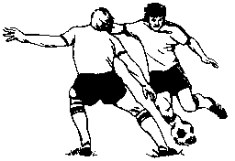

We are having an exciting event on Tuesday 26 April 2005 at the drop-in.

We are being given the opportunity by Leicester City Council to try, free of charge, various indoor sports. This is a fantastic chance for us to ‘have a go’ at things we haven’t tried before, without even having to leave the comfort of the ‘Drop-In’!

There will be Boccia and New Age Kurling amongst others.

Maybe, like me, you haven’t heard of these games, or even if you have, do you know how to play them? Well now is your chance. Come along on 26th April between 11am – 2pm and try your hand at something new.

Surprise yourself, you may find you have a hidden talent or skill for these sports,as well as a lot of fun.


Beijing Olympics watch out!

A quiz with a difference


- How long did the 100 year war last?

- Where are Panama hats made?

- What is catgut made from?

- What are the Canary Islands named after?

- What was King George’s first name?

- What colour is a purple finch?

- Where do Chinese gooseberries come from?

- What colour is an aeroplanes black box?

- In what month do the Russians celebrate the October revolution?

10. What is a camel hair brush made from?

The following has been reproduced by kind permission
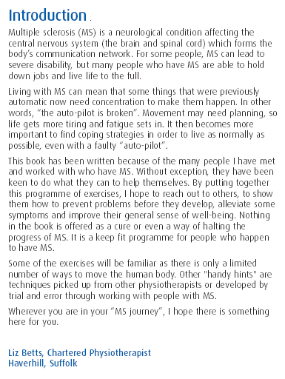
of the MS Trust from their booklet entitled ‘Exercises for people with MS’
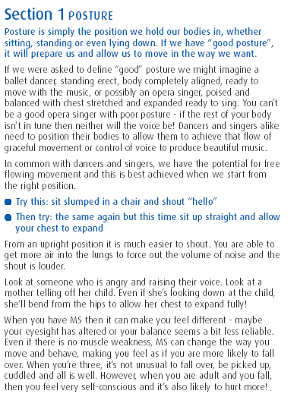
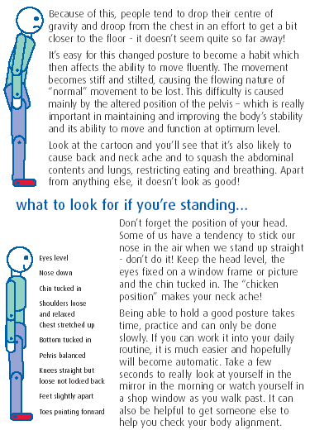
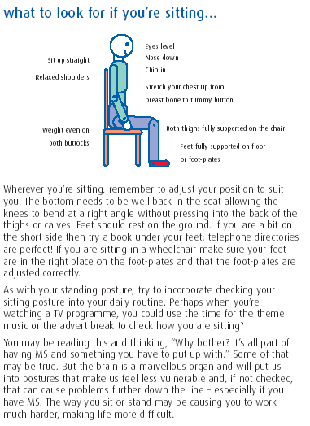

The Drop-In Diary

Date | Professional | Subject
5 April 05 | Jade | Hand & Nail care
5 April 05 | Val | Relaxation/Meditation
12 April 05 | Raakhee McNulty | Reflexology/Alternative Therapies
12 April 05 | Julie Tolton | Chiropody
15 April 05 |  | St James the Greater Church London Road Auction of Promises
19 April 05 | Val | Relaxation/Meditation
19 April 05 | Alison | MS Nurse
26 April 05 |  | Have a go indoor sports come along and try something new
3 May 05 |  | Ulverscroft Grange £6.00 max 12 persons see Jane Tindle.
3 May 05 | Jade | Hand & Nail care
3 May 05 | Val | Relaxation/Meditation
10 May 05 | Raakhee McNulty | Reflexology/Alternative Therapies
17 May 05 | Val | Relaxation/Meditation
1 17 May 05 | Alison | MS Nurse
24 May 05 | Julie Tolton | Chiropody

Date | Professional | Subject
7 June 05 | Jade | Hand & Nail care
7 June 05 | Val | Relaxation/Meditation
14 June 05 | Raakhee McNulty | Reflexology – Alternative Therapies
21 June 05 | Val | Relaxation/Meditation
28 June 05 | Alison | MS Nurse
4 July 05
12 July 05
19 July 05
26 July 05

If you have any suggestions for day trips, evenings out, speakers at the ‘Drop-in’ etc please let me know and we will try to arrange it.

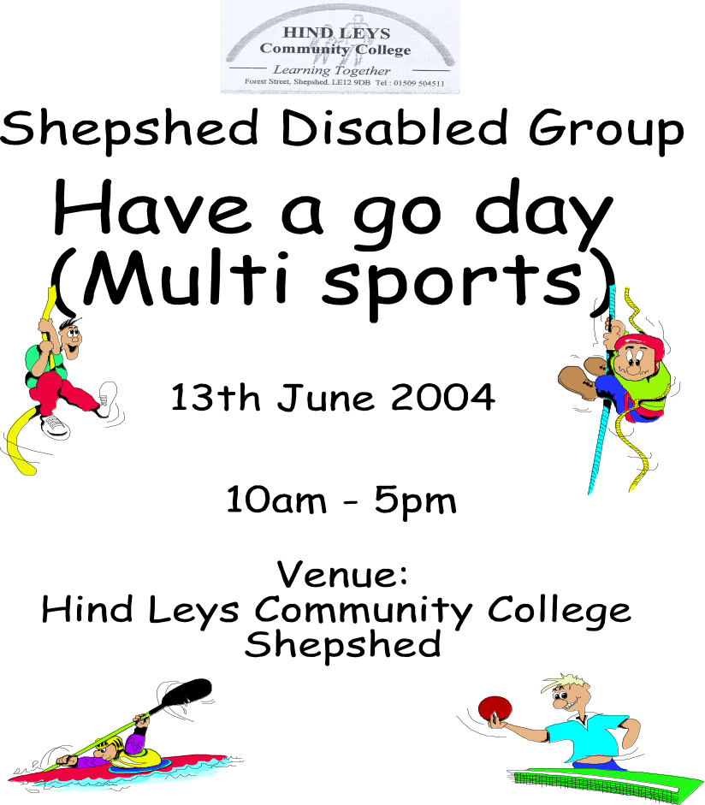

12th June 2005

Please sign in at reception on arrival
Snack bar serving food and drink will be open all day
Licensed bar 12.00 – 3pm, BBQ and picnic area
Swimming kit is required to take part in canoeing, swimming or sub aqua. Trousers are required for horse riding.

Contact Nina & John Walker (01509) 506392

Please help us

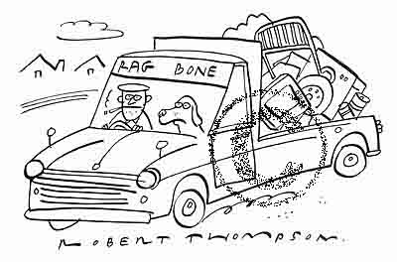

Did you know that by recycling various items you could help raise money for The Leicester Branch of the MS Society?

All the following items can be recycled

Aluminium cans

Saucepans
Teapots
Brass taps

Door handles
Clocks
Copper pipes
Ornaments

In fact, practically any non ferrous metal objects

Contact Ken on 0116 2206847
Please deliver your items to the drop-in on a Tuesday.
Collection can be arranged for any very large items.
To help with opening jars, bottle tops and turning door handles, either wear rubber gloves or affix thick rubber bands for grip. Rubber bands can also help you to hold on to pens and pencils.
HANDY HINTS ON
COPING AROUND THE HOUSE

Keep floors as clear as possible, arrange your home for your convenience – place furniture in strategic places as supports, to help you get around.

Mail order clothes shopping means that you can take time to try things on at your own pace.

Steamers might be easier to manage than heavy saucepans of water.

A long-handled shoe horn is excellent for putting shoes on without having to bend down.

Use a carving tray or just a chopping board with spikes, to hold food still whilst chopping.

Keep frequently used items such as pens, in your pocket or in a bum bag, so that they are always accessible.

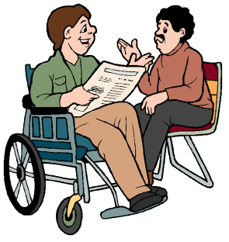
TUESDAY
Drop In sessions

EVERY TUESDAY 11am till 2pm

Easy access and car parking
Light refreshments
and disabled toilet facilities available

A Voluntary Donation is asked from those receiving Therapies to help offset the Practitioners Fees

Reflexology, chiropody, manicures and many other treatments available. See drop-in diary for dates.

Venue:- Christ the King Church
Beaumont Way
Leicester LE4 1DS
Nr TESCO’S Beaumont Leys

Round Britain Quiz The Answers
So did you find the towns and cities from ‘up north’ with the clues provided? Congratulations to Elaine Blakeman, the only correct entry received. If you are still pondering here are the answers:

Ready for the boat race? | Crewe
Famous for its pier? | Wigan
Aged, cured pork | Oldham
A dark Scottish stream | Blackburn
Kept going by the sound of it | Preston
Dark water | Blackpool
Ernie's former mate | Morecambe
This lady's fan found here? | Windermere
Stop for Mintcake | Kendal
Inhale it here? | Ayr
City of St Mungo | Glasgow
Nothing barred here | Oban
The Conqueror’s castle? | Fort William
Part of a candle | Wick
The Granite City | Aberdeen

Are you moving house,
spring cleaning or just having a good clearout?

If so please donate unwanted items to your local MS shop.

We will collect

furniture
and bric-a-brac

Phone 0116 2422240





For Sale

MEDIMOTION THERAPEUTIC EXERCISER

FULLY PASSIVE OR ASSISTED MOTION

USED VERY LITTLE
GOOD CONDITION

ONLY £300.00

(new cost £1650.00)

Contact: Mrs E Martin
Tel: 0116 2709586

www.motomed-medimotion.co.uk

The Leicester & District MS Society does not accept responsibility for any claims of, or condition of any item sold through this newsletter.

Have you any items you would like to sell?
If so, let me know!

IF I KNEW
If I knew it would be the last time
That I'd see you fall asleep,
I would tuck you in more tightly
and pray the Lord, your soul to keep.
If I knew it would be the last time
that I see you walk out the door,
I would give you a hug and kiss
and call you back for one more.
If I knew it would be the last time
I'd hear your voice lifted up in praise,
I would video tape each action and word,
so I could play them back day after day.
If I knew it would be the last time,
I could spare an extra minute
to stop and say "I love you,"
instead of assuming you would KNOW I do.

If I knew it would be the last time
I would be there to share your day,
Well I'm sure you'll have so many more,
so I can let just this one slip away.
For surely there's always tomorrow
to make up for an oversight,
and we always get a second chance
to make everything just right.
There will always be another day
to say "I love you,"
And certainly there's another chance
to say our "Anything I can do?"
But just in case I might be wrong,
and today is all I get,
I'd like to say how much I love you
and I hope we never forget.
Tomorrow is not promised to anyone,
young or old alike,
And today may be the last chance
you get to hold your loved one tight.
So if you're waiting for tomorrow,
why not do it today?
For if tomorrow never comes,
you'll surely regret the day,
That you didn't take that extra time
for a smile, a hug, or a kiss
and you were too busy to grant someone,
what turned out to be their one last wish.
So hold your loved ones close today,
and whisper in their ear,
Tell them how much you love them
and that you'll always hold them dear
Take time to say "I'm sorry,"
"Please forgive me," "Thank you," or "It's okay."
And if tomorrow never comes,
you'll have no regrets about today.

This poem was written in memory of someone who perished in the Twin Towers on 9/11, but I think the words are relevant to us all. Why not send me your favourite poem to publish in ‘The Key’ Jane
The Rules. …according to men!

Learn to work the toilet seat. You’re a big girl. If it’s up, put it down. We need it up. You need it down. You don’t hear us complaining about you leaving it down.

Saturday + Sunday = Sport. It’s like the full moon or the changing of the tides. Let it be.

Shopping is NOT a sport. And, No, we are never going to think of it that way.

Crying is blackmail.

Ask for what you want. Let me take a moment to clarify this further. Subtle hints do not work! Strong hints do not work! Obvious hints do not work! Just say it!

Yes and No are perfectly acceptable answers to almost every question.

Come to us with a problem only if you want help solving it. That’s what we do. Sympathy is what your girlfriends are for.

A headache that lasts for 17 months is a problem. See a doctor.

Anything we said 6 months ago is inadmissible in an argument. In fact, all comments become null and void after 7 days.

If you think you’re fat, you probably are. Don’t ask us.

If something we said could be interpreted two ways, and one of the ways makes you sad and angry, we meant the other one.

Whenever possible, say whatever you have to say during the adverts.

Christopher Columbus did not need directions and neither do we.

If it itches, it will be scratched. We do that.

If we ask what is wrong and you say ‘nothing’ we act like nothings wrong. We know you are lying. But it is not worth the hassle.

If you ask a question you don’t want an answer to, expect an answer you don’t want to hear.

When we have to go somewhere, absolutely anything you wear is fine. Really.

You have enough clothes.

You have too many shoes.

I am in shape. Round is a shape.

Thank you for reading this. Yes, I know. I have to sleep on the sofa tonight, but did you know men really don’t mind that. It’s like camping!

My thanks to Mandie Whetstone for this, which recently appeared in ‘Leicester Life’.
EXERCISE

Effects of a 6-month exercise program on patients with multiple sclerosis.
Authors: A Romberg, A Virtanen, J Ruutianen,
S Aunola, S-L Karppi, M Vaara, J Surakka, T
Pohjolainen & A Seppanen.
Place of Report: Helsinki, Finland.
Journal Reference: Neurology, 2004. Vol. 63,
pages 2034-2038.

Research Summary
Over time a number of people with MS develop problems with walking, which can impact on other aspects of their daily lives and lead to reduced independence. Cardiovascular exercise has been shown to have a beneficial impact on fitness, fatigue and quality of life in the general population and people with MS. However, the effect of strengthening exercises for people with MS is not fully clear. This study evaluated the effects of a six-month, home-based exercise programme, incorporating both cardiovascular and strengthening exercises, on mobility in people with MS.

95 people with mild to moderate MS completed the study. Half were randomly assigned to the exercise programme (the test group) and the remaining 50% continued with their standard level of activity (the control group). Walking speed, and upper and lower limb strength were assessed at the start and end of the six-month programme. Participants in the test group received three weeks of supervised training and were prescribed an individually tailored programme by a physiotherapist. The test group were asked to complete three weekly strength training sessions and one aerobic session per week. Results showed that, on average, those in the test group were significantly quicker at the 7.5m and 500m timed walks, at the end of the study, than those who did not undertake additional exercise. Similarly, arm strength also improved significantly in the test group, shown by a greater number of weight repetitions. No increase in MS activity or relapse rate was reported with increased exercise, compared to the control group.
There was wide variation between participants in the number of sessions completed by the test group. Only 59% of strength training sessions were completed with 24% of the exercise group completing less than one third of the prescribed strength training. Consequently, the authors suggest that continuous guidance and support may be crucial for a successful programme completion. In summary, these results show that long term exercise can lead to significant and clinically meaningful improvements in walking speed and endurance for people with mild to moderate MS.

Key messages
. Loss of mobility is a major problem for many people with MS and can impact on independence.
. 95 people with MS took part in a six month, home-based cardiovascular and strengthening exercise programme.
. Half were assigned strength training sessions three times a week and aerobics sessions once a week. The remainder continued with their normal level of exercise.
. Results showed people in the exercise
group were quicker at walking over distances of 7.5m and 500m at the end of the exercise programme.
. However, only 56% of the strength training sessions were completed, with 24% of people completing less than one third of these sessions.
. The authors suggest that continuous guidance and support may be crucial for successful programme completion.
. Long-term exercise can lead to significant and clinically meaningful improvements in walking speed for people with mild to moderate MS.

So with this in mind I decided to try some exercise myself and you could too, if you are interested look at the next article.


Would you like to become fitter?
When did you last visit a gym or an aerobic exercise class?

Well, now is your chance. Active Lifestyle is a partnership between the the Health Authority, local councils, GP Practices and other Health Care Professionals. It offers people who are inactive or who have a condition that could benefit from physical activity, the opportunity to participate in exercise. This is under the guidance of qualified exercise professionals, at a convenient venue in the local community and at a special reduced rate.

The first thing to do is to pay your GP a visit. If you are eligible and you both feel it is appropriate, a referral form is completed for you, recording your blood pressure, weight and height details. Once completed, you keep one copy and the other is sent to your local participating council. You will need to check in advance if the fitness/leisure centre you wish to join takes part in this scheme. The leisure centre/council will then contact you to arrange an Induction session. Depending on the area in which you live, a variety of activity programmes are available including exercise to music, aquaerobics, exercise in a fitness suite/gym, walking and chair-based exercise.

It is important for everyone to keep as active as possible, this can help

- maintain your weight within a desirable range

- make you feel more energetic and lively

- relieve stress and tension

- prevent and manage lower back pain


- keep your joints mobile and your muscles and bones strong

So what are you waiting for?

Local co-ordinator contact numbers are:

Leicester City 0116 2333018
Blaby 0116 2750234
Charnwood 01509 634836
Harborough 01858 821284
Hinckley & Bosworth 01455 891854
Melton 01664 502331
NW Leics 01530 454606
Oadby & Wigston 0116 2572735

I have now been twice myself on the Active Lifestyle Scheme at the Soar Valley Leisure Centre at Mountsorrel I have taken a friend with me to help me, and the staff at the gym have been exceptionally helpful. I went along to an induction session and they showed me how to use the equipment. I wasn’t the least bit self conscious or embarrassed which I thought I might be. I now have a programme so I know what to do each time I go. I have already found this beneficial, I cannot walk any better, but have noticed that I am much more supple in my hips and knees and nowhere near as stiff as usual.

There are also swimming sessions (there is a hoist) and aerobics/fitness classes if you prefer this kind of exercise.

So, why not give it a go, if I can, you can!
SPORTABILITY

As many of you know, during the better weather, Sportability (www.sportability.org) arrange various events for people with disabilities. Several of us from the drop-in attend these sports and have a brilliant time, so why not join us? All the sports are free for the disabled person.

24 April 10.30am – 12.30pm - Quad biking at Leicester Outdoor Pursuits Centre

24 April 1.00pm – 3.00 pm – Indoor archery at Leicester Outdoor Pursuits Centre

15 May 10.30am – 12.30pm – Canoeing at Leicester Outdoor Pursuits Centre

26 May 10.30am – 12.30pm – Falconry at Twin Lakes Park at Melton Mowbray
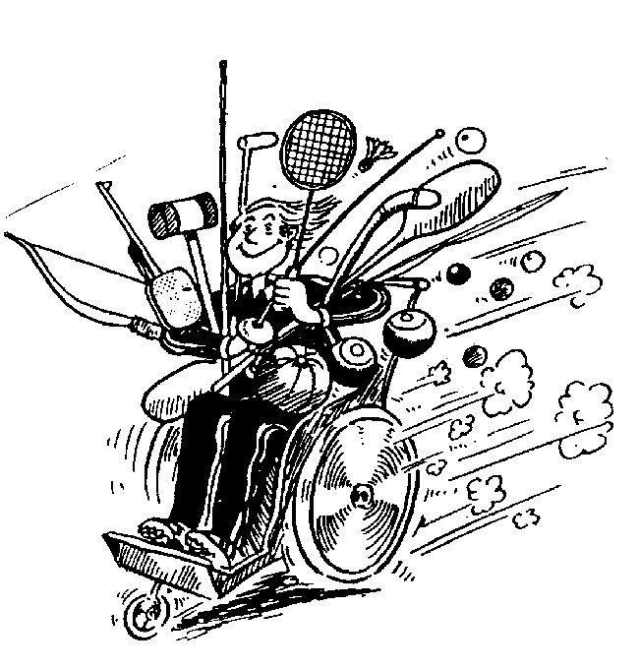

If you would like to come along to any of these dates please contact Jane on 01509 414201 to book a place.



What do you call a grumpy and short- tempered gardener? A snap dragon.

What can you hold without even touching it?

A conversation

What do you get if you cross a chicken with a cement mixer? A brick layer

What do you call it when worms take over the world? Global worming.
A weed is a plant that has mastered every survival skill except for learning how to grow in rows.

This publication has been printed by
TEAMPRINT
Loughborough

01509 261425



Jane Tindle
45 Melton Road Barrow on Soar
Loughborough
Leics
LE12 8NS

jane@tindle01.fsnet.co.uk

01509 414201

Send me your contributions for the next issue- on any topic.
By 30 April 2005 please

